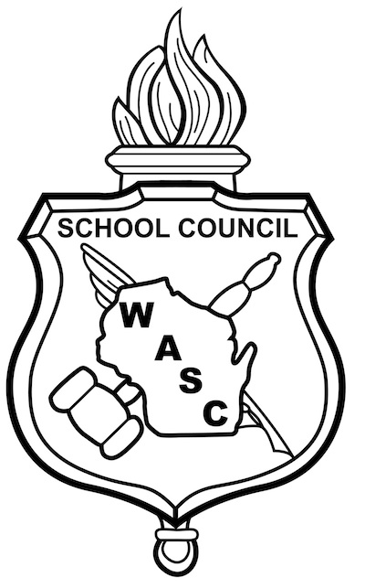
Wisconsin Association of School Councils
Regional Officer Application - Student

One of the most important positions at WASC is Regional Officer. Members of this exclusive body are responsible for coordinating activities for and representing the thousands of Junior and Middle School (JAM) and Senior High School (SHS) students in their WASC State Region.
Each year, regions elect one SHS and one JAM president, vice president and secretary for a one-year term. Only two students per school may run for each office. The regional officers meet regularly throughout the year with their regional advisors. In addition, each JAM and SHS president represents her/his region on the WASC Governing Board, which is the governing body for the organization.
Thank you for your interest in representing your region in this pivotal role. Past regional officers and governing board members agree that their job as an officer was an enormous part of their educational experience. It goes beyond being a member of an activity, group or team; it is a chance to gain experience running an actual non-profit business.
To be eligible, students must:
- Be a current member of student council or have previous student council experience
- Have at least one year of attendance remaining at their corresponding level (SHS or JAM)
- Be available to attend regional meetings (virtually this year) during the school year
- Submit this form to WASC before November 10, 2020
Elections are held during the Fall Tour Regional Business Meetings on SUNDAY, November 15, 2020, where students running for a position are required submit to the State Office a 1-2 minute speech and one page resume. If you are unable to provide a video, please contact Michelle McGrath (michelle@wasc.org) to make other arrangements. Information on WASC’s governing structure is available at www.wasc.org/governance

Name
I wish to apply for the following position for WASC Region _______

Senior High School President Middle/Junior High School President

Senior High School Vice-President Middle/Junior High School Vice-President

Senior High Corresponding Secretary Middle/Junior High Corresponding Secretary

Name ______________________________________
About you
Home Address ______________________________________ City ___________________________________ Zip
Phone ____________________________________________ Email
Parent/Guardian Name(s)
Parent/Guardian Email

About your school
School Name
Address ___________________________________________ City ___________________________________ Zip
Principal
Student Council Advisor

Please attach a resume of achievements and experience with the WASC.

Please return this form to by November 10, 2020
WASC, 4797 Hayes Rd, Madison, WI 53704 or stateoffice@wasc.org

I recognize the responsibility associated with this position and if elected, I am willing to devote my time and talent to do an effective job.
Print Name: _____________________________________ Signed:

As parent(s) or guardian(s), I/we support 's candidacy for this WASC office. I/we know the position is for one year and the responsibility will involve several meetings at a regional and perhaps state level.
Print Name: _____________________________________ Signed:
Print Name: _____________________________________ Signed:

As 's Student Council Advisor, I support her/his candidacy for this WASC office. My signature verifies her/his qualifications for the position.
Print Name: _____________________________________ Signed:

As 's Principal, I support her/his candidacy for the WASC office indicated above. Our school will permit this candidate to attend and participate in WASC events should they be occasionally scheduled on school days.
Print Name: _____________________________________ Signed:

